**Spring Security Assignments**

1) Design and develop a Spring security Hello World application by using default login form provided by spring security to secure URL access say, for example to access the content of an “admin” page, user needs to enter valid credentials. User must also logged out if successfully logged in.

Use Java Based and annotation-based configuration and In-memory authentication.

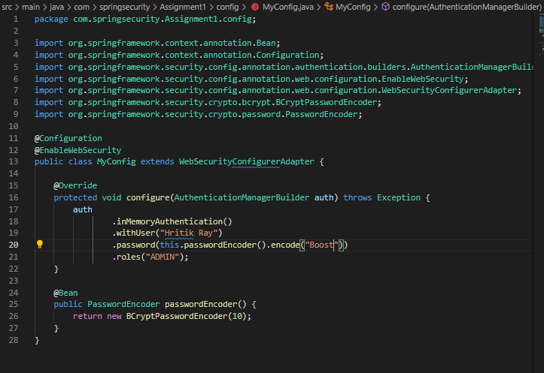

**Controller**

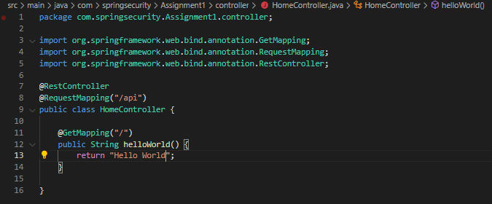

**Output:**

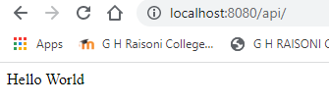

2) Modify the above application to use custom login form instead of default login form provided by spring security. Use Java Based and annotation based configuration and In-memory authentication.

**Controller**

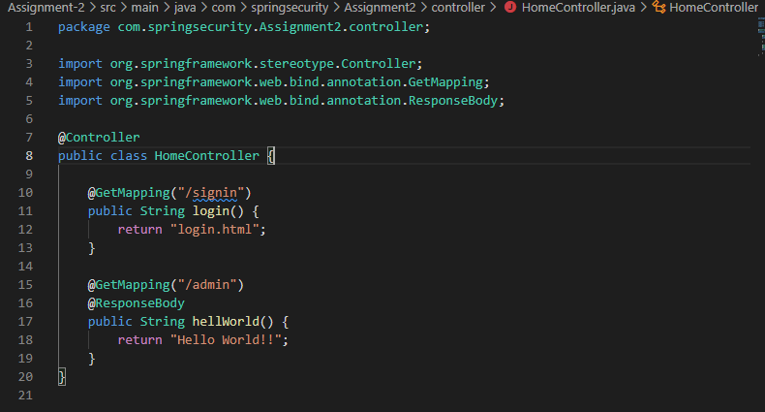

**Login Page**

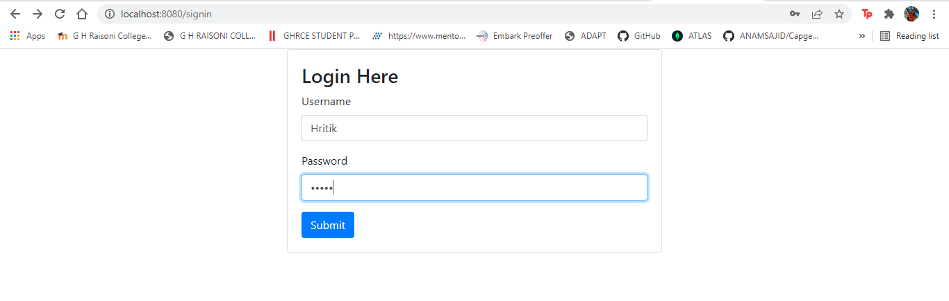

**For invalid username**

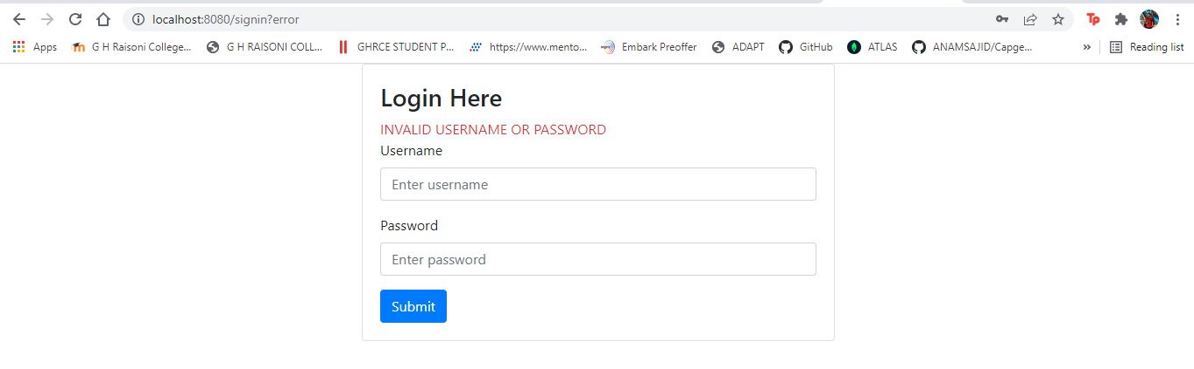

3) Modify the above application and use database authentication using JDBC instead of Inmemory authentication. Use Java Based and annotation based configuration and In-memory authentication.

**Config**

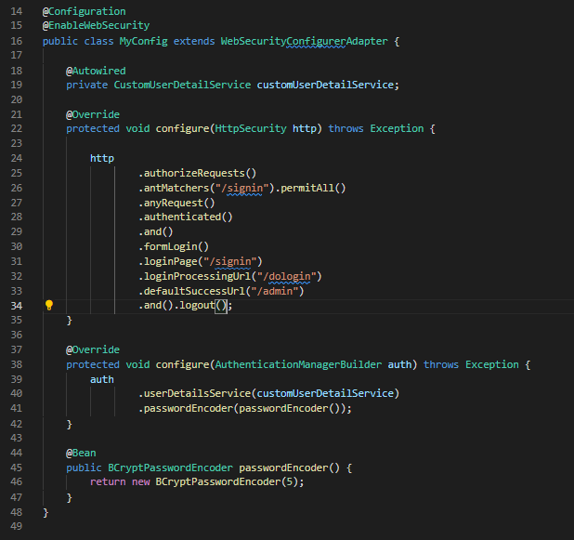

**controller**

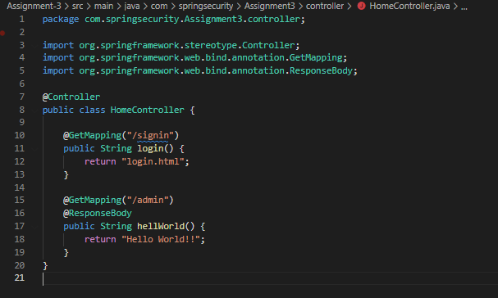

**Database accessed after login credentials**

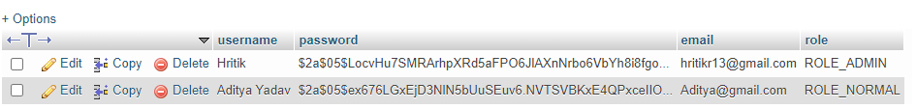

**Output**



5) Modify the above application to implement “remember me” functionality.

**Remember me functionality added**

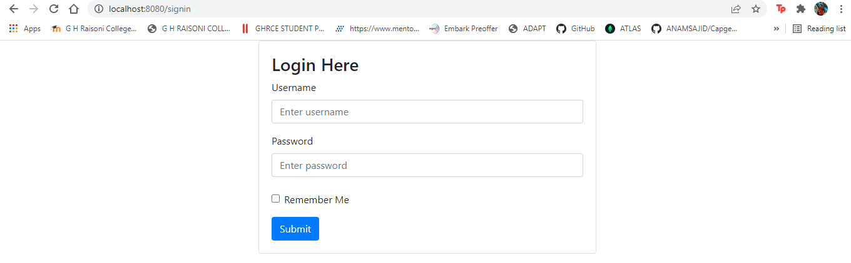

**Config**

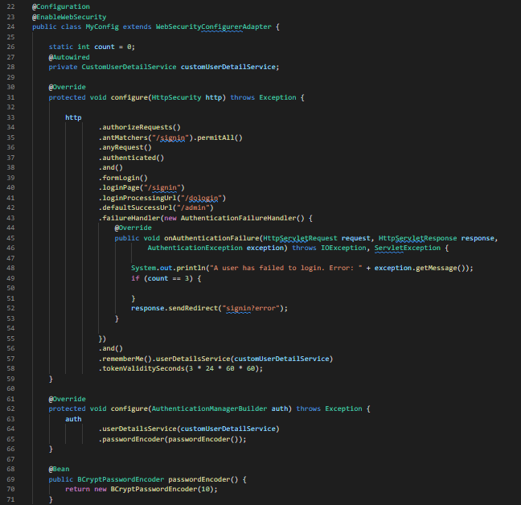

6) Modify the above application to secure the password by encoding it. (You may use some encryption technique)

**Controller**

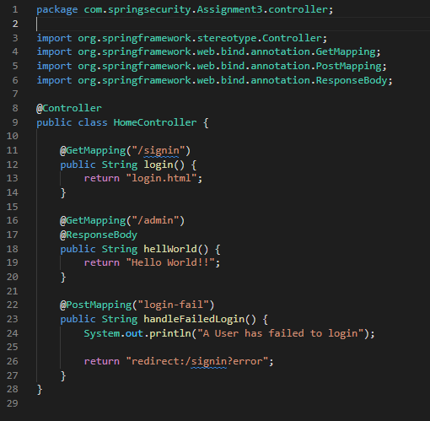

**Encrypted password**

